Software Requirements Specification
for
<Project>
Version <X.X>

Prepared by
Group Name: <place your group name here>
<name> | <student #> | <e-mail>
<name> | <student #> | <e-mail>
<name> | <student #> | <e-mail>
<name> | <student #> | <e-mail>
<name> | <student #> | <e-mail>

Instructor: | <place your instructor’s name here>
Course: | <place your course name here>
Date: | <place the date of submission here>

Contents
Contents ii
Revisions ii
1 Introduction (P1) 1
1.1 Document Purpose 1
1.2 Product Scope 1
1.3 Intended Audience and Document Overview 1
1.4 Definitions, Acronyms and Abbreviations 1
1.5 References and Acknowledgments 1
2 Overall Description (P1) 2
2.1 Product Overview 2
2.2 Product Functionality 2
3 Specific Requirements (P1 & M1) 2
3.1 Functional Requirements (P1) 2
3.2 Use Case Model (P1) 3
3.3 Wireflow (P1) 3
4 Technical Design (M1) 5
4.1 Entity Relationship Diagram (ERD) 5
4.2 Class Diagram 5
4.3 Activity Diagram 5
4.4 Gantt Chart 5
5 Risk Assessment (P2) 5
5.1 Risk Assessment 5

Revisions
Version | Primary Author(s) | Description of Version | Date Completed
Draft Type and Number | Full Name | Information about the revision. This table does not need to be filled in whenever a document is touched, only when the version is being upgraded. | 00/00/00

Introduction (P1)
<TO DO: Please provide a brief introduction to your project and a brief overview of what the reader will find in this section.>

Document Purpose
<Identify the product whose software requirements are specified in this document, including the revision or release number. Describe the scope of the product that is covered by this SRS, particularly if this SRS describes only part of the system or a single subsystem.
TO DO: Write 1-2 paragraphs describing the purpose of this document as explained above.>

Product Scope
<Provide a short description of the software being specified and its purpose, including relevant benefits, objectives, and goals.
TO DO: 1-2 paragraphs describing the scope of the product. Make sure to describe the benefits associated with the product.>

Intended Audience and Document Overview
<Describe the different types of reader that the document is intended for, such as developers, project managers, marketing staff, users, testers, and documentation writers (In your case it would probably be the “client” and the professor). Describe what the rest of this SRS contains and how it is organized. Suggest a sequence for reading the document, beginning with the overview sections and proceeding through the sections that are most pertinent to each reader type.>

Definitions, Acronyms and Abbreviations
<Define all the terms necessary to properly interpret the SRS, including acronyms and abbreviations. You may wish to build a separate glossary that spans multiple projects or the entire organization, and just include terms specific to a single project in each SRS.
TO DO: Please provide a list of all abbreviations and acronyms used in this document sorted in alphabetical order.>

References and Acknowledgments
<List any other documents or Web addresses to which this SRS refers. These may include user interface style guides, contracts, standards, system requirements specifications, use case documents, or a vision and scope document. >

Overall Description (P1)

Product Overview
<Describe the context and origin of the product being specified in this SRS. For example, state whether this product is a follow-on member of a product family, a replacement for certain existing systems, or a new, self-contained product. If the SRS defines a component of a larger system, relate the requirements of the larger system to the functionality of this software and identify interfaces between the two. In this part, make sure to include a simple diagram that shows the major components of the overall system, subsystem interconnections, and external interface. In this section it is crucial that you will be creative and provide as much information as possible.

TO DO: Provide at least one paragraph describing product perspective. Provide a general diagram that will illustrate how your product interacts with the environment and in what context it is being used. This is not a formal diagram, but rather something that is used to illustrate the product at a high level.>

Product Functionality
<Summarize the major functions the product must perform or must let the user perform. Details will be provided in Section 3, so only a high level summary is needed here. These can be at the level given in the project description.>
TO DO:
1. Provide a bulleted list of all the major functions of the system

Specific Requirements (P1 & M1)

Functional Requirements (P1)
< Functional requirements capture the intended behavior of the system. This behavior may be expressed as services, tasks or functions the system is required to perform.

ID | AS A < TYPE OF USER > | I WANT TO < PERFORM SOME TASK > | SO THAT I CAN < ACHIEVE SOME GOAL >
1 | Project Manager | View a status report from each team member | Ensure the project stays on track.
2 | Employee | Be reminded of upcoming deadlines | Complete my tasks on time.
3 | Director | See the big picture view of department work | Stay in the loop.

Use Case Model (P1)
TO DO: Provide a use case diagram that will encapsulate the entire system and all actors.
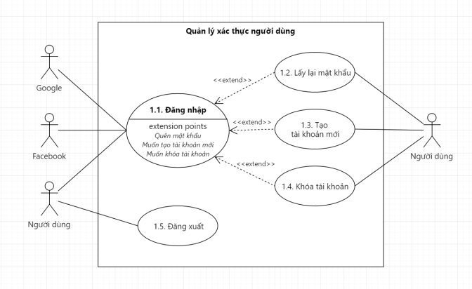

Wireflow (P1)
<Describe the logical characteristics of each interface between the software product and the users. For your project, you only need to be concerned with the main thermostat (not the mobile app) and can use the graphic from the project description as the basis for your user interface..
TO DO: Provide the graphic for the thermostat user interface and provide a basic description as to how users will interact (e.g. tough screen, menus, etc.).>

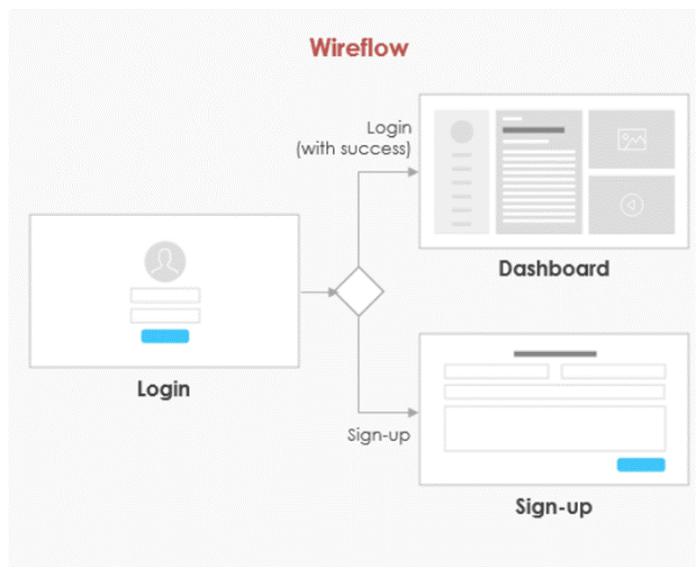

Technical Design (M1)

Entity Relationship Diagram (ERD)

Class Diagram

Activity Diagram

Gantt Chart

Risk Assessment (P2)

Risk Assessment
Identify and list Hazards |  | List Current Risk Controls | Risk Rating | List Additional Controls (if any - where current controls are not adequately managing the level of risk)
1
2
3

